Funding
Design example:
Compliance with ethical standards.
If studies were conducted with people.
Design example:
If studies were conducted with animals.
Design example:
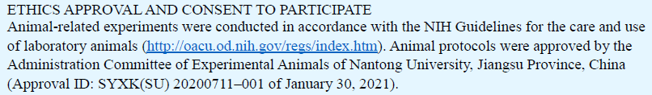
Conflict of interest
Section design samples:
If one author is male:
If one author is a woman:I
If there is one author, the gender is not obvious:
If there are two or more authors:

